Name: Arnav Deo | SAP ID: 60004230285
Date of Performance: 21/08/2024 | Date of Submission: 28/08/2024
Experiment No: 3
Aim: Write a program to implement error detection and correction
Techniques: CRC, Hamming(4, 7) implementation
Program:
#include <stdio.h>

int get_bit_count(int num)
{
int bit_shift = 1;
while (num >= (1 << bit_shift))
{
bit_shift++;
}
return bit_shift;
}
int calculate_crc(int payload, int divisor)
{
int div_bit_count = get_bit_count(divisor);
int payload_bit_count = get_bit_count(payload);
int shifted_payload = payload << (div_bit_count - 1);
int shifted_payload_bit_count = get_bit_count(shifted_payload);
int div_shift_bit_count = shifted_payload_bit_count - div_bit_count;
int shifted_div = divisor << div_shift_bit_count;
printf("Payload: %08b [%d]\nDivisor: %08b [%d]\nShiftPl: %08b [%d]\n", payload, payload_bit_count, divisor, div_bit_count, shifted_payload, shifted_payload_bit_count);
printf("ShiftDv: %08b [%d]\n", shifted_div, div_shift_bit_count);
while (div_shift_bit_count)
{
printf("[%d] %08b ^ %08b = %08b\n", div_shift_bit_count, shifted_payload, shifted_div, shifted_payload ^ shifted_div);
shifted_payload ^= shifted_div;
shifted_div >>= 1;
div_shift_bit_count -= 1;
}
return shifted_payload;
}

int main()
{
int payload = 0;
int divisor = 1;
printf("Enter payload: ");
scanf(" %d", &payload);
printf("Enter divisor: ");
scanf(" %d", &divisor);
int crc = calculate_crc(payload, divisor);
printf("Calculated CRC is %b\n", crc);
}

#include <stdio.h>
#include <stdlib.h>

int get_bit_count(int num)
{
int bit_shift = 1;
while (num >= (1 << bit_shift))
{
bit_shift++;
}
return bit_shift;
}

int get_parity_bit_count(int message)
{
int m = get_bit_count(message);
int p = 1;
while ((1 << p) < (p + m + 1))
{
p++;
}
return p;
}

int get_bit_from_lsb(int val, int pos)
{
return (!!(val & 1 << pos)) ? 1 : 0;
}

int get_bit_from_msb(int val, int pos)
{
int bc = get_bit_count(val);
return get_bit_from_lsb(val, bc - (pos + 1));
}

int calculate_hamming_code(int message)
{
int m = get_bit_count(message);
int p = get_parity_bit_count(message);
int total_bit_count = m + p;
printf("Using %d bits for the message with %d m bits and %d p bits\n", total_bit_count, m, p);
int *parity_offset_map = malloc(sizeof(int) * p);
if (parity_offset_map == NULL)
{
return 0;
}
int ham_mask = 0;
for (int p_bit_msb_offset_mul = 0; p_bit_msb_offset_mul < p; p_bit_msb_offset_mul++)
{
int parity_bit_offset = ((total_bit_count - 1) - ((1 << p_bit_msb_offset_mul) - 1));
*(parity_offset_map + p_bit_msb_offset_mul) = parity_bit_offset;
ham_mask |= 1 << parity_bit_offset;
}

int ham_code = 0;
int src_bit_index = 0;
for (int i = 0; i < total_bit_count; i++)
{
int is_mask = get_bit_from_lsb(ham_mask, i);
if (is_mask)
{ /* Do nothing */
}
else
{
// Get the bit from the actual value
int src_bit = get_bit_from_lsb(message, src_bit_index);
ham_code |= src_bit << i;
src_bit_index++;
}
}

printf("Your Message in Binar: %032b\n", message);
printf("Hamming Bit Positions: %032b\n", ham_mask);
printf("Code with Mesg Filled: %032b\n", ham_code);

for (int i = 0; i < p; i++)
{
int pos = 1 << i;
// Start with 1 for odd parity, 0 for even parity
int parity = 0;
for (int j = 1; j < total_bit_count + 1; j++)
{
// Easier to count 1, 3, 5, 7 rather than 0, 2, 4, 6
int real_pos = j - 1;
if (j & pos)
{
// The position is covered by the current hamming bit
// This also includes the hamming bit as well,
// but it will be set to 0 always, giving us the parity value in the end
int pos_bit = get_bit_from_msb(ham_code, real_pos);
parity ^= pos_bit;
}
}

// Good thing we are keeping track of where the parity bit will end
int par_offset_from_lsb = parity_offset_map[i];
ham_code |= parity << par_offset_from_lsb;
}

printf("Code with Hamming ECC: %032b\n", ham_code);
printf("Code only Hamming Bit: %032b\n", ham_code & ham_mask);

return ham_code;
}

int main()
{
int message = 0;
printf("Enter message: ");
scanf(" %d", &message);
int hamming_code = calculate_hamming_code(message);
return 0;
}

Screenshots:
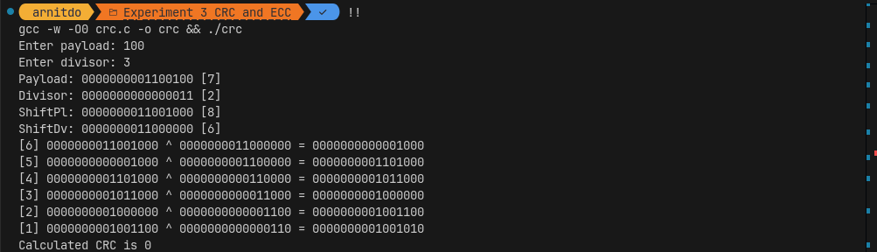
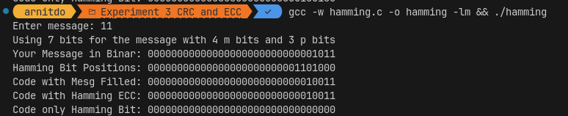

Conclusion:
Thus, we have studied and implemented the various error detection and correction.

